Assignment 1

In Q2b) it is noticed that the difference between training and test error increases as the degree of polynomial increases. So it is a clear indication that model overfits for higher degrees. So I would prefer to go with a degree 5 polynomial which doesnot overfits and consequently has lower test error compared to higher degrees. The lower degree plynomials ie 1,2,3, and4 cannot train the model properly so has pretty high training error, which is not acceptable.

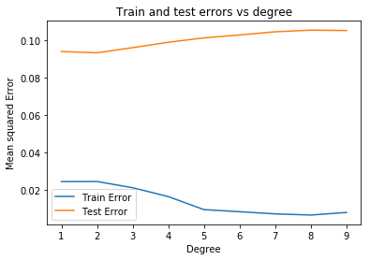

Now, comming to Q3)
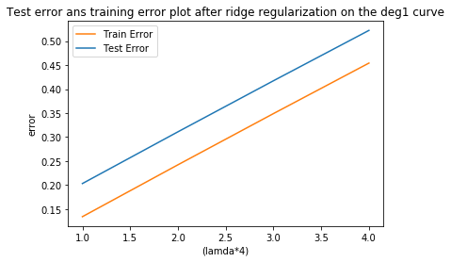
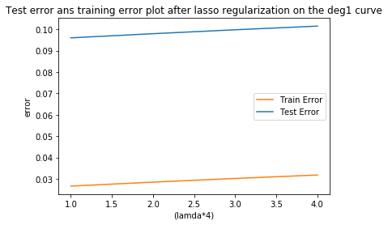
The regularisation is done to prevent overfitting. So here our purpose is served as the training error for degree 8 polynomial has significantly increased.

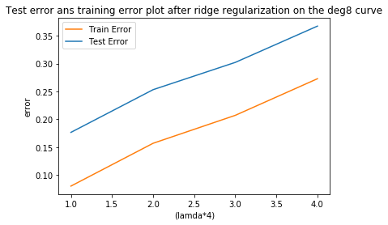
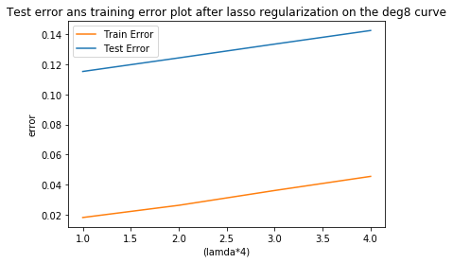
From these two plots it can be clearly seen that ridge regularization decreases the difference between training and test error. But on the other hand, the error(both training and test) for ridge regulariation is fairly large compared to lasso. So since deg1 model does not have the overfitting problem so lasso regularization works better than ridge for this case.

In this case, the overfitting problem is serious, so ridge regularisation reduces the difference between training and test error significantly compared to lasso. So in ths case ridge regularization with lamda=0.25 will work better. Finally all errors increases with increase of lamda which is as expected.

